ESG Narrative Analysis and Prediction of Financial Index Volatility Using Text Mining and Machine Learning
Mercer, Antonio Carlos (Department of Business Administration Program, Pontifical Catholic University of Parana, Curitiba, PR, Brazil) mercer.antonio@grupomarista.org.br
Filho, Zacarias Curi (Department of Computer Science Program, Pontifical Catholic University of Parana, Curitiba, PR, Brazil) zcurif@gmail.com
Póvoa, Ângela Cristiane Santos (Department of Business Administration Program, Pontifical Catholic University of Parana, Curitiba, PR, Brazil) angela.povoa@pucpr.br
Abstract
Motivated by the growing significance of Environmental, Social, and Governance (ESG) factors and the market's pronounced sensitivity to real-time information, this study empirically examines the reaction of the New York Stock Exchange (NYSE) to ESG-related news. Leveraging a specialized news corpus, our methodology integrates a Large Language Model (LLM)-driven Natural Language Processing (NLP) pipeline with a classic event study to assess abnormal returns and trading volume. Our findings indicate a pronounced asymmetry in market reaction, whereby the financial penalties associated with negative news substantially exceed the rewards from positive news. Furthermore, we identify a selective and heterogeneous response: the market distinguishes between the distinct impacts of the Environmental, Social, and Governance pillars and focuses its reaction primarily on events of high materiality. Ultimately, this research establishes that the price discovery of ESG information is a dynamic process, conditional on news sentiment, thematic pillar, and the materiality of the reported event.
Key-words: Sustainable Finance – ESG – Artificial Intelligence.
Introduction
Environmental, Social, and Governance (ESG) factors have become increasingly integral to corporate strategy and investment analysis. Investor demand for firms with strong ESG performance has grown substantially, with evidence suggesting that such practices are perceived as indicators of lower risk and quality management (Friede, Busch & Bassen, 2015). Consequently, a firm's disclosure and performance on ESG metrics can significantly influence capital allocation decisions.
Financial markets are powerful information-processing systems, with news media acting as the primary conduit for corporate disclosures. A vast body of literature confirms that stock prices rapidly incorporate the financial implications of significant events, both positive and negative. This process of price discovery is not merely a technical feature; it is fundamental to market efficiency and directly informs investor decision-making.
Given the convergence of ESG's growing importance and the market's rapid reaction to news, a critical question arises regarding the impact of ESG-specific information. Although the literature suggests that ESG performance is valued, how investors react to discrete, real-time information on the subject remains a developing area of research. Therefore, the primary objective of this study is to empirically measure the immediate reaction of the NYSE stock market to news carrying positive and negative sentiment about corporate ESG practices.
To guide this inquiry, we address the following research questions:
RQ1: What is the magnitude and direction of abnormal stock returns following the release of news with strong positive and negative ESG sentiment?
RQ2: Does the market reaction differ across the individual ESG pillars (Environmental, Social, and Governance)?
This study contributes to existing literature in several ways. First, we employ Natural Language Processing (NLP) models to conduct a large-scale sentiment analysis on a corpus of ESG news. Second, we provide a rigorous quantification of the market reaction by focusing on immediate abnormal returns, which offers more direct evidence of the information's impact. Third, we disaggregate the analysis by the E, S, and G pillars, offering a more granular understanding than previous studies.
The remainder of this paper is organized as follows. Section 2 reviews the relevant literature. Section 3 describes the data and methodology. Section 4 presents and discusses the results. Section 5 concludes the paper, outlining implications, limitations, and avenues for future research.
Related Work
The analysis of market reactions to new information is approached from two complementary research streams. The first leverages Natural Language Processing (NLP) and sentiment analysis to extract predictive signals from unstructured textual data, such as news and social media. The second investigates the financial materiality and impact of non-financial factors, specifically Environmental, Social, and Governance (ESG), on firm performance and market valuation. The present study is positioned at the intersection of these two fields, applying sentiment analysis techniques to empirically quantify and examine the stock market's reaction to ESG-specific news events.
The evolution of sentiment analysis methodologies in finance is marked by a transition from classic, lexicon-based and traditional machine learning approaches to deep learning architecture. The most significant advance in this area was the introduction of transformer models, which substantially enhanced the contextual understanding of language. The superiority of this architecture for the financial domain was empirically established by Mishev et al. (2020). In a comparative assessment of NLP methods, the authors demonstrated the superior performance of transformers over other approaches in analyzing financial texts.
The evolution of transformer-based models has led to Large Language Models (LLMs). These models represent a massive scaling of the transformer architecture and possess an enhanced ability to comprehend the nuances and context of the texts under analysis. Such advancements position LLMs as the new frontier in sentiment analysis for finance-related texts. Following this trend, Liu et al. (2024) explores the relation between LLMs and sentiment analysis within financial markets. The authors use LLMs to investigate the correlation between news sentiment and fluctuations in bitcoin prices. The correlation they identify demonstrates the potential of using news for predicting market values and movements.
The application of sentiment analysis to textual data for forecasting financial market movements is a well-established and diverse research field. Investigations span various data sources, including Twitter (Rao & Srivastava, 2012), news articles (Nemes & Kiss, 2021), corporate reports (Li et al., 2023), and hybrid sources (Mehta, Pandya, & Kotecha, 2021).
In parallel with sentiment analysis methods, numerous researchers have been studying the impacts of ESG on financial markets and management. Kim et al. (2024) use sentiment analysis on ESG news and conclude that while ESG ratings alone do not show a direct correlation with financial performance, the sentiment analysis of these texts offers valuable insights into the potential impact of ESG management.
Another important line of research involves using ESG-related texts to predict financial market movements. In this context, Dorfleitner & Zhang (2024) investigate investor reaction to the sentiment of instant ESG news. The authors conduct their analysis based on company history and identify an abnormal average behavior for both positive and negative news. Serafeim & Yoon (2023) explore the relationship between ESG ratings, ESG-related news sentiment, and stock reactions. Their work also identifies a market reaction to ESG news and shows how this reaction behaves for different ESG ratings.
In this work, we also utilize sentiment analysis of ESG-related texts, but our interest lies in understanding the immediate reactions of the stock market. This paper distinguishes itself from others in the literature by applying state-of-the-art NLP models to analyze ESG sentiment specifically within the context of the NYSE.
Methodology
The methodology of this study employs a three-stage process to transform unstructured ESG news into a quantitative dataset suitable for an event study: (1) news acquisition and preprocessing, (2) feature extraction via a Large Language Model (LLM), and (3) integration with market data. The extraction stage, the core of this approach, utilizes the LLM to identify entities, classify the news's theme and materiality, and determines sentiment polarity within a financial context. The final stage aligns these textual attributes with price and volume time series to construct the abnormal return and volume metrics, which form the empirical basis for the subsequent analysis.
Data Acquisition and Preprocessing
The dataset for this study was constructed from news articles published in English by the ESG News portal between January 1, 2024, and April 30, 2025. The selection of this source was based on two primary criteria. First, the portal's specialization in ESG topics ensures a high density of relevant events aligned with the research scope. Second, and more importantly, the portal targets the investment community. This characteristic is fundamental to the event study's validity, as it maximizes the probability that the collected news is effectively consumed by the market participants whose reactions are being analyzed. For each article, the headline, lead paragraph, and publication date were extracted. The textual content underwent a standard normalization process, including the removal of special characters and conversion to lowercase, before being structured in JSON format for the subsequent analysis stages.
Feature Extraction from ESG News
Extracting variables from unstructured texts like news articles presents significant challenges related to scale, subjectivity, and the need for domain expertise. To overcome these challenges, this study employs a data processing pipeline based on a Large Language Model (LLM), GPT. The approach, illustrated in Figure 1, was developed to automate data annotation systematically and replicably, simulating the judgment of a market expert and ensuring consistency across the entire corpus.
Figure 1
Methodological pipeline illustrating the transformation of news articles into structured analytical records.
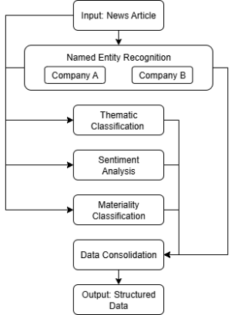
Note. Own elaboration.
The developed pipeline consists of five steps, each applied to every news article individually:
Named Entity Recognition and Disambiguation
The initial task involves recognizing all corporate entities mentioned. However, extracting names is insufficient due to potential ambiguity, such as homonyms and partial names. Therefore, the protocol implements a disambiguation step: the model is instructed to link each corporate entity to its ticker on the New York Stock Exchange (NYSE). This process ensures that each mention is unambiguously associated with a single firm listed in our market of interest, eliminating false positives and ensuring the accuracy of the subsequent time-series analysis. Entities not linkable to the NYSE are explicitly discarded. Notably, a single news article may mention multiple entities. In such cases, all subsequent steps are performed once for each firm.
Multi-Label Thematic Classification
Recognizing that ESG issues are often interrelated and not mutually exclusive, a single-label approach would be reductive. We, therefore, adopt a multi-label classification. For each news item, the model independently assesses its relevance to each of the three pillars—Environmental (E), Social (S), and Governance (G)—assigning a binary classification to each. This method allows for capturing the complexity of news that may have implications across multiple ESG domains simultaneously.
Domain-Conditioned Sentiment Analysis
Generic sentiment models often fail to capture the nuances of financial discourse. To circumvent this limitation, our methodology conditions the LLM to act as a "specialized ESG financial analyst." The adopted zero-shot domain adaptation strategy compels the model to evaluate the news polarity ("positive," "neutral," "negative") from the perspective of the expected impact on firm value and its ESG reputation, rather than a superficial linguistic analysis.
Information Materiality Classification
Not all news carries the same weight for the market. To approximate the financial concept of materiality, the pipeline includes an intensity classification stage ("strong," "neutral," "weak"). This task instructs the model to assess the news's potential to generate a significant market reaction, serving as a proxy for the magnitude of the information "shock" that each news item represents.
Data Consolidation and Consistency Assurance
Finally, the pipeline's integrity is ensured by a strict output protocol that requires all annotations for a given article to be returned as a single, atomic record in JSON format. This measure prevents data corruption or misalignment and ensures the final dataset is directly compatible with econometric analysis tools, preserving the one-to-one relationship between the event (news) and the set of extracted variables.
Data Correlation and Time Series Construction
The feature extraction pipeline yields a structured dataset where each observation corresponds to a unique (firm, news) pair, identified by its NYSE ticker and publication date. To analyze the market reaction to these events, this dataset was integrated with historical financial data extracted from the Yahoo Finance API.
The integration was performed by aligning each observation by its ticker and using the news publication date as the event day (t=0). For each ticker, a time series of daily market data was retrieved, covering the following variables: opening price, closing price, daily high, daily low, and trading volume. This process creates a unified dataset prepared for event study analysis. In cases where news was published on a non-trading day, the next trading day was considered the event day.
To quantify the market reaction, several key financial metrics were constructed. First, the daily logarithmic return was calculated for each stock, defined as Rt ​= ln(Pt​/Pt−1​), where Pt​ is the closing price on day t. Following standard event study methodology, an event and post-event window of six trading days (t to t+5) was defined. To measure the cumulative impact of the news, metrics such as the Cumulative Abnormal Return (CAR) and the average daily trading volume over this window were computed. The resulting dataset, which connects the extracted news attributes (sentiment, materiality, ESG pillar) with subsequent market behavior, forms the empirical basis for the econometric analysis presented in the following sections.
Results and Discussion
The data processing began with an initial universe of 1,612 news articles published between January 1, 2024, and April 30, 2025. The first filtering stage involved excluding weekly summary articles, a criterion adopted to isolate the market reaction strictly to the original event publication. This procedure reduced the dataset to 1,552 unique news items. Subsequently, a feature extraction process was applied to categorize each news item by firm, ticker (NYSE), ESG pillar, sentiment, and materiality. News not associated with NYSE-listed firms or not pertaining to ESG themes were then discarded as they fell outside the study's scope. The final sample used in the subsequent analyses was consolidated to 439 news articles.
From the 439 filtered news articles, 502 unique "news-firm" pairs were identified, which constitute the unit of analysis for this study. This number is higher than the total number of articles because a single publication can mention multiple NYSE-listed companies. It is crucial to emphasize that the thematic classification, sentiment analysis, and materiality identification processes were conducted independently for each of these 502 pairs, ensuring that the specific context of each firm was precisely evaluated.
The thematic distribution, based on a multi-label classification (where a news item can belong to more than one pillar), reveals a significant predominance of the Environmental pillar, present in 477 instances (95.0%). The Governance pillar was identified in 137 instances (27.3%), while the Social pillar appeared in 64 (12.8%).
Regarding sentiment analysis, a strong positive bias was observed in the sample: 423 instances (84.3%) were classified as Positive, 54 (10.8%) as Negative, and 25 (5.0%) as Neutral. For the market reaction analysis (event study), only news with positive and negative sentiment were considered, excluding neutral items as they lack an expected directional impact.
The materiality classification analysis, as detailed in Table 1, reveals a notable concentration of news in the strong-positive category, which, with 383 articles, constitutes the most significant pattern in the study's instances. An equally relevant insight is the strong correlation between sentiment and intensity; this means that news with a defined polarity, both positive and negative, tends to be predominantly classified as high-intensity. This is evidenced by the 53 cases of high-intensity negative news, contrasting with a negligible presence in other intensity levels. Conversely, neutral-polarity news shows a more balanced distribution, suggesting that in the absence of a clear sentiment, the news intensity does not follow a specific trend.
Table 1
Distribution of News Articles by Polarity and Materiality.
Polarity/ Materiality | Weak | Neutral | Strong
Negative | 1 | 0 | 53
Neutral | 7 | 11 | 7
Positive | 11 | 29 | 383
Note. Own elaboration.
Proceeding from the sample characterization to the analysis of market reaction, the first indicator investigated was abnormal trading volume, which serves as a proxy for investor attention. This indicator was calculated as the percentage deviation of trading volume in a given period from its historical average. Overall, the results indicate that ESG news causes a consistent, albeit modest, 3% increase in trading volume, a level that is sustained over the five-day post-event window. This initial finding confirms that news on this topic is indeed relevant to the market.
However, a deeper analysis reveals a notable asymmetric reaction based on news sentiment. Negative sentiment events trigger an immediate and significantly higher peak in attention, with a 6% increase in volume on the event day. This increase is more than double that recorded for positive news, which generates an increase of only 2%. This finding corroborates the literature on loss aversion and suggests that the greater rarity of negative events endows them with a higher informational load, distinguishing them from positive news, which may be perceived as part of routine corporate communications.
The analysis by ESG pillar reveals an even more nuanced and, in some respects, counterintuitive dynamic. Notably, the Social pillar demonstrated the greatest ability to attract investor interest. News in this category generated a 5% increase in volume on the event day, a reaction that intensifies to 8% when considering the five-day window, suggesting growing and sustained interest. This indicates that although the Environmental pillar dominates media coverage, investors react more robustly to social topics, perhaps because they perceive their financial impacts—such as strikes or product safety issues—as more immediate and tangible.
In stark contrast, news related to the Governance pillar showed no statistically significant change in trading volume. This result does not diminish the importance of governance but rather suggests that its impact may not be a trigger for short-term trading. Instead, it may be a factor absorbed by the market over longer time horizons, defining an important boundary for the immediate effect of ESG news. Finally, the Environmental pillar, with a 2% volume increase, behaved similarly to the overall average, serving as a baseline for comparison with the more pronounced effects observed in the other categories.
While abnormal trading volume quantifies market attention, the central objective of this study is to measure the tangible economic impact of ESG news, assessed through abnormal stock returns. Figure 2 presents the mean impact on closing price by news sentiment polarity. As can be observed, news with positive sentiment generates an immediate positive abnormal return of +0.22% on the event day. This gain not only sustains but also amplifies significantly in the following days, reaching a cumulative return of +0.49% over the five-day window. This phenomenon, known as Post-Announcement drift, suggests an initial market underreaction, with the market gradually absorbing the good news. For management, this represents clear evidence that investments in positive ESG practices translate into shareholder value creation, although this appreciation may take several days to be fully incorporated into the stock price.
Figure 2
Mean impact on closing price by news sentiment polarity.
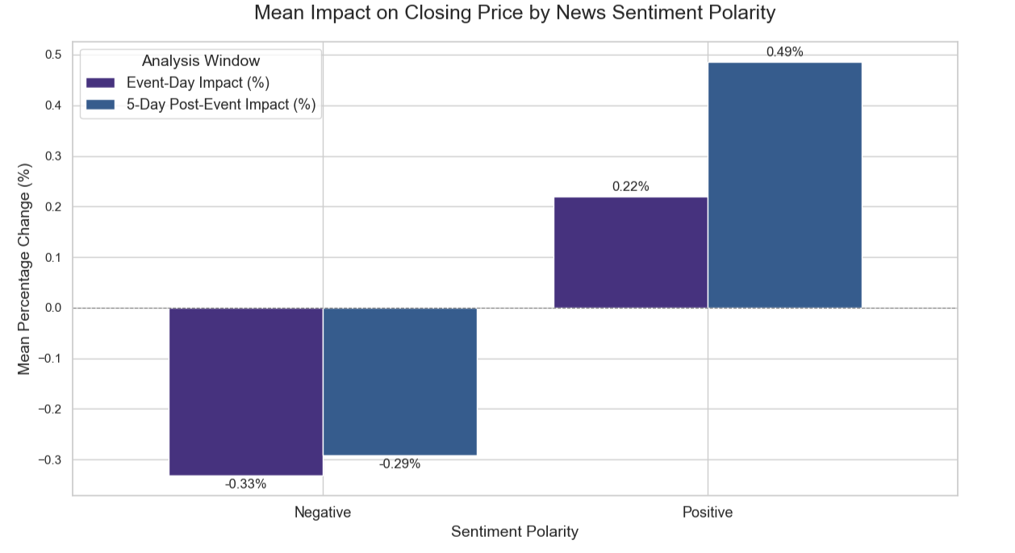
Note. Own elaboration.
In contrast, the impact of negative news is more severe and immediate. On the event day, such news causes an average decline of -0.33% in firm value. One of the central contributions of this study is the evidence of this strong asymmetry: the market penalty for a negative news item is substantially greater than the reward for a positive one in the short term. This finding aligns with behavioral finance theories, such as loss aversion, and serves as a critical warning for managers about the importance of proactive ESG risk management. Furthermore, the five-day cumulative negative return slightly attenuates to -0.29%, indicating a small correction after an initial market overreaction.
The disaggregated analysis by ESG pillar, presented in Figure 3, reveals distinct pricing mechanisms, reflecting different levels of informational maturity and valuation complexity. Governance news triggers the largest immediate impact (+0.24%), a sharp price adjustment consistent with the Efficient Market Hypothesis. In contrast, the Social pillar exhibits a clear pattern of Post-Announcement Drift, with a modest initial return (+0.10%) that evolves into the largest five-day cumulative gain (+0.46%), a phenomenon linked to the market's difficulty in quantifying the value of intangible assets. Finally, the Environmental pillar demonstrates a stable and positive valuation trend (from +0.16% to +0.39%), indicating a more mature pricing stage.
Figure 3
Mean impact of esg news on closing price.
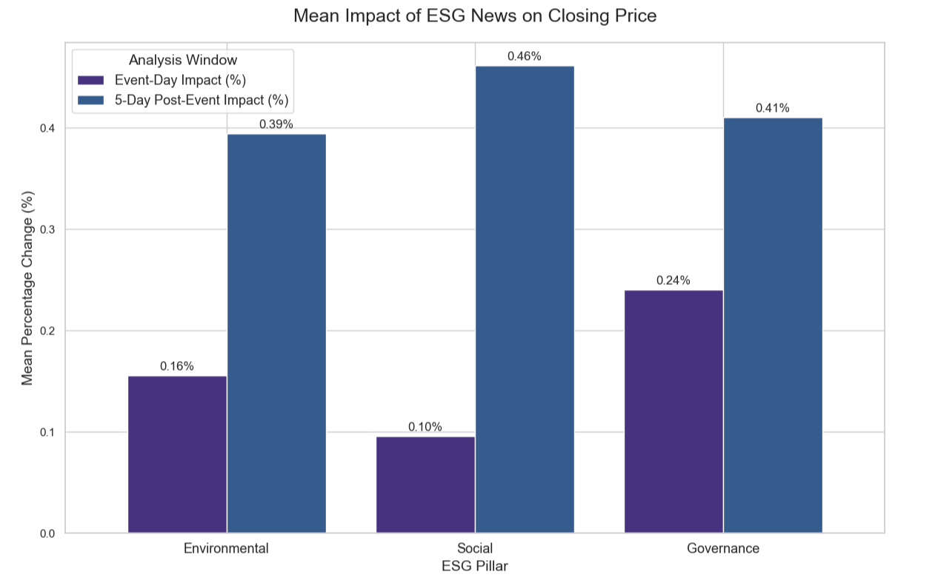
Note. Own elaboration.
The quantification of the medium-term impact, measured by the average cumulative log return over the five days following the event, confirms the heterogeneous pricing dynamics among the pillars. The results, presented in Figure 4, reinforce the prominence of the Social pillar as the primary value driver over the period, showing the highest cumulative return with an average of 0.40%. The Environmental pillar follows with a robust and similarly-sized appreciation, recording 0.36%. In sharp contrast, and confirming the dissipation of its strong initial impact, the Governance pillar showed the smallest cumulative effect, at 0.15%. These data highlight a clear separation between the market's immediate reaction and the perceived value creation in the medium term, indicating that while governance events trigger rapid adjustments, it is Social and Environmental practices that consolidate as the most significant drivers of sustained appreciation within the analysis window.
Figure 4
Mean 5-Day Cumulative Log Return by ESG Pillar.
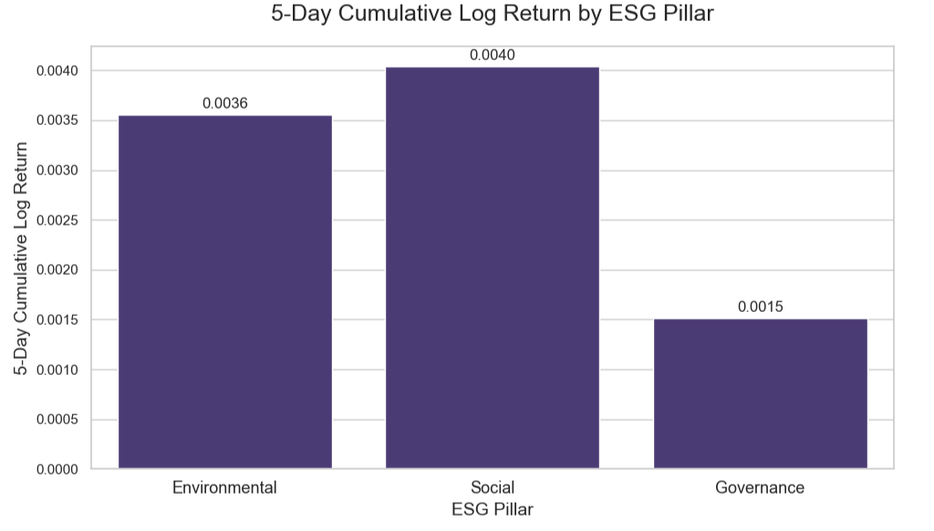
Note. Own elaboration.
The analysis of the distribution of Cumulative Abnormal Returns (CAR), presented in Figure 5, provides a necessary deep-dive into the mean returns previously discussed. A central fact revealed by the data is that the median return (50th percentile) for all pillars is statistically indistinguishable from zero. This demonstrates that the median ESG event does not lead to a change in stock price. The direct implication is that the observed non-zero mean returns are a product of skewed distributions, where events with extreme returns, or outliers, influence the aggregate result.

Figura 5
Distribution of 5-day cumulative abnormal returns (CAR) by ESG pillar.
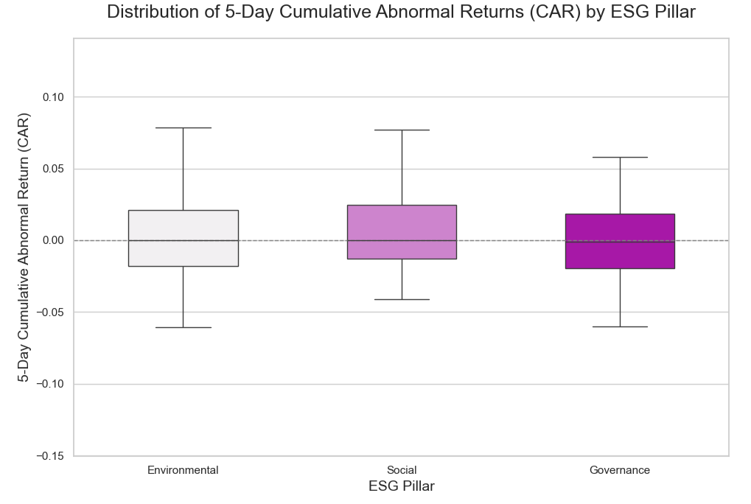
Note. Own elaboration.
The distribution of returns for the Social pillar exhibits a pronounced positive skew. With the highest mean return (+0.74%), its distribution shows a 75th percentile (+2.44%) considerably more distant from the median than its 25th percentile (-1.28%). This quantitative pattern is consistent with the previously identified Post-Announcement Drift phenomenon, where medium-term appreciation is driven by a subset of events with a large positive impact.
In contrast, the Governance pillar is the only one to exhibit a negative average cumulative return (-0.19%). This result contrasts with the previous observation of a significant positive return on the event day. The distribution of returns for this pillar thus indicates that the short-term gains associated with some news items are outweighed by the medium-term losses from other events. The distributional analysis exposes a reversal of the initial impact when considering the totality of events in the five-day window.
The Environmental pillar, in turn, presents the most symmetric distribution among the three categories. The slightly positive mean return (+0.14%) is accompanied by a relatively balanced dispersion around the median. This statistical profile aligns with the earlier conclusion that the market's pricing of environmental news is more stable and predictable, without the strong positive skew of the Social pillar or the negative average outcome of the Governance pillar.
In summary, the empirical analysis reveals a complex and selective landscape of market reaction to ESG news, marked by a strong asymmetry where the penalty for negative events is more severe and immediate than the reward for positive events. The finding that the median ESG event has a null impact demonstrates that this reaction is not generalized but is concentrated in high-materiality occurrences. This selectivity results in a clear hierarchy of financial impact: the Social pillar emerges as the most consistent driver of value creation, propelled by a return distribution with a strong positive skew; in contrast, the Governance pillar, despite a strong initial impact, represents a distinct risk profile, where the negative average cumulative return shows that losses associated with failures outweigh the average gains. Thus, the study moves from a general question about the relevance of ESG to an empirical mapping of how, when, and which dimension effectively drives or exposes corporate value.
Conclusion and Future Work
The central objective of this study was to empirically measure and analyze the reaction of the NYSE stock market to news with positive and negative sentiment regarding corporate ESG practices. Through a methodology that integrates advanced Natural Language Processing (NLP) and a rigorous event study framework, we have provided direct and nuanced answers to the research questions that guided this work.
In response to our research questions, our findings reveal a markedly asymmetric market reaction. News with negative sentiment triggers a more severe and immediate price drop than the gradual and initially more modest gain generated by positive news. Additionally, we demonstrated that the market reaction is highly heterogeneous across pillars: the Social pillar emerges as the most consistent medium-term value driver; the Governance pillar presents a paradoxical profile, with a strong initial impact that is not sustained, revealing a negative average risk; and the Environmental pillar exhibits a more stable and mature pricing dynamic. The analysis is deepened by the finding that the median impact is null, indicating that the market is selective and that price reactions are concentrated on high-materiality events.
The implications of these findings are relevant for both theory and practice. From a theoretical standpoint, the observed phenomena of Post-Announcement drift and overreaction challenge the strong-form Efficient Market Hypothesis and provide evidence for behavioral finance models. For management, the results offer a strategic guide: the strong penalty for negative news highlights the critical importance of ESG risk management, while the superior performance of the Social pillar suggests a clear path for allocating capital to value-creating initiatives. For investors, the study reveals the insufficiency of static ratings and the importance of real-time news analysis for a more dynamic risk assessment.
Despite its robust findings, this study has limitations that open avenues for future research. Our analysis focuses on the NYSE market. Future work could expand the geographical scope and data sources, for instance, by aggregating news comments and user reactions on social media to build a more holistic view of market sentiment. Additionally, future investigations could further explore the causes of the Governance pillar's risk profile and the interaction between news sentiment and firm-specific characteristics, such as size, industry, and their pre-existing ESG rating. Such studies will continue to enhance our understanding of how the ESG narrative is priced within the complex ecosystem of financial markets.
References
Dorfleitner, G., & Zhang, R. (2024). ESG news sentiment and stock price reactions: A comprehensive investigation via BERT. Schmalenbach Journal of Business Research, 76(2), 197–244. https://doi.org/10.1007/s41471-023-00166-z
Friede, G., Busch, T., & Bassen, A. (2015). ESG and financial performance: Aggregated evidence from more than 2000 empirical studies. Journal of Sustainable Finance & Investment, 5(4), 210–233. https://doi.org/10.1080/20430795.2015.1118917
Kim, M., Kim, S., Kim, Y., & Moon, J. (2024). Analyzing the financial impact of ESG news sentiment on ESG finance trends. In 2024 International Conference on Platform Technology and Service (PlatCon) (pp. 95–100). IEEE. https://doi.org/10.1109/PlatCon59929.2024.00024
Li, H., Peng, Q., Wang, X., Mou, X., & Wang, Y. (2023). Sehf: A summary-enhanced hierarchical framework for financial report sentiment analysis. IEEE Transactions on Computational Social Systems, 11(3), 4087–4101. https://doi.org/10.1109/TCSS.2023.3301465
Liu, C., Arulappan, A., Naha, R., Mahanti, A., Kamruzzaman, J., & Ra, I. H. (2024). Large language models and sentiment analysis in financial markets: A review, datasets and case study. IEEE Access. https://doi.org/10.1109/ACCESS.2024.3384230
Mehta, P., Pandya, S., & Kotecha, K. (2021). Harvesting social media sentiment analysis to enhance stock market prediction using deep learning. PeerJ Computer Science, 7, e476. https://doi.org/10.7717/peerj-cs.476
Mishev, K., Gjorgjevikj, A., Vodenska, I., Chitkushev, L. T., & Trajanov, D. (2020). Evaluation of sentiment analysis in finance: From lexicons to transformers. IEEE Access, 8, 131662–131682. https://doi.org/10.1109/ACCESS.2020.3008662
Nemes, L., & Kiss, A. (2021). Prediction of stock values changes using sentiment analysis of stock news headlines. Journal of Information and Telecommunication, 5(3), 375–394. https://doi.org/10.1080/24751839.2020.1857516
Rao, T., & Srivastava, S. (2012). Analyzing stock market movements using Twitter sentiment analysis. In Proceedings of the 2012 International Conference on Advances in Social Networks Analysis and Mining (ASONAM 2012) (pp. 119–123). https://doi.org/10.1109/ASONAM.2012.26
Serafeim, G., & Yoon, A. (2023). Stock price reactions to ESG news: The role of ESG ratings and disagreement. Review of Accounting Studies, 28(3), 1500–1530. https://doi.org/10.1007/s11142-023-09750-4
Song, C., Zhao, Z., Liang, X., & Fu, Y. (2025). The impact of news sentiment on exchange rate volatility: A study based on AI sentiment analysis. In Proceedings of the 2025 4th International Conference on Cyber Security, Artificial Intelligence and the Digital Economy (pp. 228–234).

